

**Smarter Balanced**

**Assessment Consortium:**

**Fixed Form Packager User Guide**

August 29, 2018

Overview of the Fixed Form Packager 3

Installing, Building, and Running the Fixed Form Packager 3

Installation Requirements 3

Acquiring the Source Code 3

Building and Running the FFP 3

Command Line Options 4

Command Line Example 5

Schema Validation 5

GitLab Integration 5

GitLab Account 6

GitLab URL 6

GitLab Groups 6

GitLab API Token 6

Constructing the Excel Workbook Input File 7

Sheet Layout 8

Package Sheet 9

Scoring Sheet 10

Tests Sheet 12

Segments Sheet 12

SegmentForms Sheet 13

Tools Sheet 16

# Overview of the Fixed Form Packager

The Fixed Form Packager (FFP) is a command-line Java application that ingests a Microsoft Excel workbook in .XLSX format and generates a fixed form test package XML document.

# Installing, Building, and Running the Fixed Form Packager

## Installation Requirements

This project uses the following tools for building and installing the Fixed Form Packager:

* Java 1.8
* Maven 3

## Acquiring the Source Code

The source code for the FFP and additional installation instructions can be found at <https://github.com/SmarterApp/TDS_FixedFormPackager>. There are two options for downloading the source code. The first option is to navigate to the FFP web page where there is a button to download the source code as a zip file as shown in Figure 1.

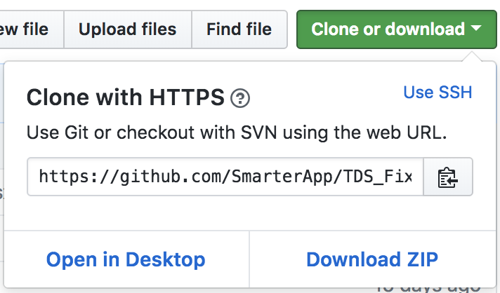

Figure 1: Download FFP code by clicking the "Clone or download" button.

Once the code has been downloaded, decompress the downloaded Zip file. This will result in the creation of the TDS_FixedFormPackager directory.

The second option for downloading the source code is to clone it using git with the shell command:

git clone <https://github.com/SmarterApp/TDS_FixedFormPackager.git>

Both options will result in the creation of the TDS_FixedFormPackager directory.

## Building and Running the FFP

After the installation requirements have been fulfilled, use a terminal application to execute the commands in this section to build and run the Fixed Form Packager.

Change directories to the TDS_FixedFormPackager directory and execute the following commands in a shell:

mvn clean install

This command will compile and run the tests for the Fixed Form Packager. As this command successfully completes, a new “target” directory will be created at the top of the TDS_FixedFormPackager directory. Inside this directory will be the newly built Java Archive file (JAR file) with a similar name to “target/tds-fixed-form-packager-081320182115.jar”. The last segment of the JAR’s filename is a timestamp indicating the date and time that it was built. Your filename will differ from the examples here, so be sure to use the correct file name.

java -jar target/tds-fixed-form-packager-081320182115.jar -h

This command will run the FFP and display the help message below detailing the command-line options available.

The fixed-form test package was not successfully created

Error message: Missing required options: t, g, u

usage: Sample usage: <INPUT XLSX> [OPTIONS]

-d,--debug Prints more verbose debug output in case of errors

-g,--group <group> *REQUIRED* GitLab Group

-h,--help Prints help statement and exits

-o,--output <output> Output path of the generated test package file

(current directory by default)

-t,--token <token> *REQUIRED* GitLab Token

-u,--url <url> *REQUIRED* GitLab URL

## Command Line Options

Along with the path to the Excel input file, the FFP has available a number of command line options, some of which are required, and some are optional. These command line options are detailed in Figure 2.

|  |  |  |  |  |
| --- | --- | --- | --- | --- |
| Argument | Long Option | Required | Description | Example |
| Path_to_XLSX | NA | Yes | The input Excel file containing the test package information. Must be in .XLSX format and not in .XLS format. | ./SBAC-IAB-FIXED-G11M-Winter-2017-2018.xlsx |
| -g | --group | Yes | GitLab Group containing the Item metadata | -g ffp-development |
| -h | --help | No | Prints out the help/usage statement and exits. | -h |
| -o | --output | No | Output path of the generated test package file. (current directory by default) | -o ffp-output-directory |
| -t | --token | Yes | GitLab token | -t YOUR_GITLAB_TOKEN |
| -u | --url | Yes | GitLab URL | -u https://gitlab-dev.smarterbalanced.org/ |
| -d | --debug | No | Verbose logging which can help identify errors | -d |

Figure 2: Command line options

### Command Line Example

The example below leverages all of the command line options listed above.

java -jar target/tds-fixed-form-packager-081320182115.jar SBAC-IAB-FIXED-G11M-Winter-2017-2018.xlsx -g ffp-development -o ffp-output-directory -t YOUR_GITLAB_TOKEN -u https://gitlab-dev.smarterbalanced.org/ -d

The above command will take the Excel document

SBAC-IAB-FIXED-G11M-Winter-2017-2018.xlsx

as input and generate the test package file

ffp-output-directory/SBAC-IAB-FIXED-G11M.xml

assuming that the output directory

ffp-output-directory

previously exists.

### Schema Validation

The FFP performs XSD schema validation on the test package XML document it produces. If the schema validation fails, however, it will still write the test package document to the output directory.

# GitLab Integration

The Fixed Form Packager combines the information provided in the Excel input file with the information from the Item metadata.xml file and Item release data file (e.g. item-200-XXXX.xml) stored in a private GitLab instance to generate a fixed form test package. Where attributes from the Excel workbook and the GitLab information overlap, the Excel workbook takes precedence.

## GitLab Account

Users of the FFP must have an account on the Smarter Balanced GitLab instance where the Item metadata is stored.

## GitLab URL

Smarter Balanced operates its own instance of GitLab in order to store Item information. This is ***not*** the public instance of GitLab at <https://gitlab.com>. The FFP requires the URL of the GitLab instance that has the Item metadata and item release data XML files that will be included in the test package. This URL is specified with the -u or --url flag on the command line. An example of a URL might be <https://gitlab-dev.smarterbalanced.org/>.

## GitLab Groups

You must be a member of the GitLab group you are attempting to access at least the Guest level. The group can be determined by browsing an Item's metadata and copying the URL segment between the base GitLab URL and the Item directory. For example, if you were browsing the Item metadata at <https://gitlab-dev.smarterbalanced.org/ffp-development/item-XXX-YYYYY> then the GitLab Group would be "ffp-development". You can find the groups you are a member of by clicking the  icon in the top-left corner of the GitLab webpage and selecting “Groups” from the drop down menu.



Figure 3: Select "Groups" from the dropdown menu.

## GitLab API Token

Your GitLab token can be generated by going to your profile in your GitLab instance and selecting the "Access Tokens" link.



Figure 4: Click on the triangle in the top-right of the page and select "Profile"



Figure 5: Click the link "Access Tokens."

If you do not already have a token, fill out the form as shown in Figure 6 to create one and copy the token value somewhere safe. This value is a *required* command line option (-t or --token) by the Fixed Form Packager in order for it to read the Item metadata and Item release files from the GitLab API.

1. Give the token a “Name” of your choosing.
2. Select the date for the token to expire.
3. Select the “api” and “read_user” checkboxes.



Figure 6: Fill out the token form as shown.

Once you fill out the form, you will be presented with your access token as shown in Figure 7. This is the first and only time your token will be presented to you. If you navigate away from this page, you will need to generate a new token. Copy your token value somewhere safe.



Figure 7: Copy your access token somewhere safe. Once you leave this page you won't be able to access it again.

# Constructing the Excel Workbook Input File

The input document to the Fixed Form Packager is a Microsoft Excel workbook in .XLSX format (***not***.XLS format!). Examples can be found in the following table:

|  |  |
| --- | --- |
| Test Package Name | Fixed Form Packager Input File |

|  |  |
| --- | --- |
| SBAC-IAB-FIXED-G7E-Winter-2017-2018 |  |
| SBAC-IAB-FIXED-G11M-Winter-2017-2018 |  |
| SBAC-ICA-FIXED-G11E-Winter-2017-2018 |  |
| SBAC-ICA-FIXED-G11M-Winter-2017-2018 |  |

## Sheet Layout

The workbook contains multiple worksheets (Package, Scoring, Tests, Segments, SegmentForms, and Tools) as seen in Figure 8. You can select the different worksheets by clicking the tabs at the bottom of the Excel document.



Figure 8: The different worksheets as tabs on the bottom of the Excel workbook.

Each worksheet represents input to a section of the resulting test package document. For example, the highest level “Package” worksheet contains the highest-level information in the test package including the test package ID, the Bank Key, Academic Year, and more.

In addition, each worksheet has multiple header rows at the top describing the columns below and giving additional information to guide the entry of the data into the worksheet as shown in Figure 9.

|  |  |  |
| --- | --- | --- |
| Column Header | Description | Example |
| Version | Version of the specification | 2.0 |
| Input Data Values and Descriptions | Marks the columns that give descriptions of the input values as well as the variable name that the FFP uses to lookup the value |  |
| # of Entries Allowed | Indicates whether the worksheet allows multiple columns of entries to be input for singular or repeating elements | Only 1 Package ID Allowed,  1 Or More TestId's Allowed Per TestPackageID,  Multiple ItemId's Allowed Per Segment |
| XML Reference | The hierarchical path to the element in the resulting XML document for the value in this row | TestPackage-publisher will fill the element attribute :  <TestPackage publisher="SBAC" /> |
| Usage | Whether the row entry value is required or optional |  |
| Input Variable Description | A helpful description of the value that should be entered in that row | ID of the test package,  Test grade - comma separated list of grades |
| Input Variable | Internal variable name that the FFP uses to look up the value | PackageId, SegmentFormPosition, ToolType_1 |
| Input Parameter | The value for that row. Enter your data in this colum. |  |

Figure 9: Worksheet headers.

The areas of the worksheet are also color-coded to separate the template and description areas. The cells with both dark and light gray background are the template areas and generally should not have their values changed. The only exception to this is when repeating elements are added by copying and pasting rows at the bottom of the document and changing the Input Variable names to reflect the new set of parameters as with the ItemScoreParameters in the SegmentForms sheet. Additional description of this scenario will be discussed in the worksheets that require these changes. The user input area has a white background and is where the user should enter their data.

The next sections will discuss each of the worksheets, working from left to right across the tabs on the bottom of the Excel document starting with the Package worksheet and ending with the Tools worksheet.

### Package Sheet



Figure 10: The Package worksheet.

The Package sheet defines the entries for the top-level <TestPackage> element as well as the Blueprint/Scoring/PerformanceLevels. All of the entries are required except for the AssessmentSubtype row.

### Scoring Sheet



Figure 11: The Scoring worksheet.

The Scoring worksheet primarily defines the BlueprintElement/Scoring/Rules section of the test package. The first 4 rows, BluePrintElementId, BlueprintElementType, ComputationalOrder, and Rule name, are required, and the rest are optional.

#### Adding Additional Rules

As indicated by the “One Rule Per Column” header, additional Rules can be added to the Scoring worksheet by adding additional columns to the right of the last column and keeping the headers for that column intact. A reliable technique for accomplishing this without error is to select an entire “Input Parameter” column by clicking on the lettered column indicator at the very top of the Excel worksheet (for example column “H”) to highlight the entire column (see **Error! Reference source not found.**), use your computer’s copy feature, and then enter it into the column after the last “Input Parameter” to the right side of the worksheet by again selecting the first empty column’s lettered column header (for example column “AK” in Figure 13) and using paste. Then change any fields that need to be changed in that column.

|  |  |
| --- | --- |
| Figure 12: Select an entire row to copy by clicking on the column header. | Figure 13: Select first empty column to paste copied column into. |

#### Rule Parameters

Rule Parameters are defined in groups per Rule column by the naming convention of the Input Variable column. The rule parameters use a numbering convention of <PARAM>_X_Y where X and Y are integer values. The values used for X and Y must be sequential (e.g. 1, 2, 3, etc.).

If there is only one set of Rule Parameters defined in the input Excel document, then the user would fill out the values for the group containing optional Input Variables stopping before reaching ParameterType_2, which marks the beginning of the next group of Rule Parameters. This example is shown below:

ParameterType_1,

ParameterName_1,

ParameterPropertyName_1_1,

ParameterPropertyValue_1_1,

ParameterComputationRuleIndex_1_1,

ParameterComputationRuleValue_1_1,

ParameterComputationRuleIndex_1_2,

ParameterComputationRuleValue_1_2,

ParameterComputationRuleIndex_1_3,

ParameterComputationRuleValue_1_3

The first integer after the first underscore “_” indicates the Rule Parameter group. Within a group of Rule Parameters there *may* be more than one pair of ParameterComputationRuleIndex and ParameterComputationRuleValue entries. These are indicated by the second integer in the Input Variable name. For example ParameterComputationRuleIndex_1_2, and ParameterComputationRuleValue_1_2 are the second set of ParameterComputationalRuleIndex and ParameterComputationRuleValues within the first set of Rule Parameters.

To add an additional set of Rule Parameters, copy all of the rows from one of the existing sets and paste it at the bottom being careful to properly modify the two integer values after the underscores. For example, if a 5th Rule Parameter needed to be added, the user could copy the rows for the 4th group and paste them below the last row as seen in Figure 14.



Figure 14: Copying and pasting a Rule Parameter group.

Then the user should clear out the Input Parameter values and renumber the Input Variable values to

ParameterType_5,

ParameterName_5,

ParameterPropertyName_5_1,

ParameterPropertyValue_5_1,

ParameterComputationRuleIndex_5_1,

ParameterComputationRuleValue_5_1,

ParameterComputationRuleIndex_5_2,

ParameterComputationRuleValue_5_2,

ParameterComputationRuleIndex_5_3, and

ParameterComputationRuleValue_5_3

as seen in Figure 15.



Figure 15: Change Rule Parameter group numbers and enter new data.

### Tests Sheet



Figure 16: The Tests worksheet.

The Tests worksheet identifies one or more <Test> elements in the test package. Both the TestId and TestLabel are required and must be unique. More than one Test can be defined by adding additional columns to the right on the worksheet as seen in Figure 17.

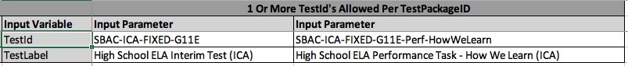

Figure 17: Two Tests defined with two Input Parameter columns.

|  |  |
| --- | --- |
|  | **Reminder:** The TestId values are referenced in both the Segments worksheet and the Tools worksheet. Make sure that the values are the same. |

### Segments Sheet



Figure 18: The Segments worksheet.

The Segments worksheet defines the one or more <Segment> elements within a <Test> element.

Segments are linked to a Test via the TestId in that the TestId entered in the Segments worksheet must match a Test from the Tests worksheet. If more than one Segment has the same TestId, then those segments will appear in the same Test, and their order will be determined by the SegmentPostion. For example, Figure 19 shows 3 different Segments with the following SegmentIds:

* SBAC-ICA-FIXED-G11E
  + Belongs to Test with TestId SBAC-ICA-FIXED-G11E
* SBAC-ICA-FIXED-G11E-Perf-HowWeLearn**A**
  + Belongs to Test with TestId SBAC-ICA-FIXED-G11E-Perf-HowWeLearn
* SBAC-ICA-FIXED-G11E-Perf-HowWeLearn**B**
  + ***Also*** belongs to Test with TestId SBAC-ICA-FIXED-G11E-Perf-HowWeLearn

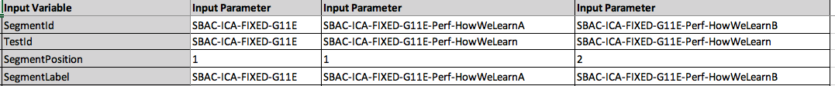

Figure 19: Three Segments belonging to two different tests.

The second and third Segments, SBAC-ICA-FIXED-G11E-Perf-HowWeLearnA and SBAC-ICA-FIXED-G11E-Perf-HowWeLearnB, are both members of the Test with TestId SBAC-ICA-FIXED-G11E-Perf-HowWeLearn. As such they must be ordered within the Test, which is accomplished by assigning the appropriate SegmentPosition to each of them.

To add additional Segments add additional columns to the right of the worksheet as discussed in previous sections.

|  |  |
| --- | --- |
|  | **Reminder:** The SegmentId values are referenced in SegmentForms worksheet. Make sure that the values match where appropriate. |

### SegmentForms Sheet



Figure 20: The SegmentForms worksheet.

#### SegmentForms Overview

The SegmentForms worksheet defines the SegmentForms, Presentations, ItemGroups, and Items within a test package and associates them with the proper Segments. The input to this worksheet is a set of columns each with attributes about a specific item in a test package. Based on those attributes of an Item like SegmentFormId, SegmentFormPosition, and ItemPosition, as well as whether or not it has an Associated Stimulus Id (<associatedpassage>) in the GitLab item release metadata, determines the grouping of SegmentForms, ItemGroups, and Items. All items referenced on the SegmentForms sheet must be accessible in GitLab as discussed in the GitLab integration section.

|  |  |
| --- | --- |
|  | **Reminder:** The SegmentId values referenced in SegmentForms worksheet must match with SegmentIds in the Segments worksheet. |
|  |  |

#### Relationships and Rules

The following rules illustrate the relationships established by the Item Input Parameters:

* Items with the same SegmentId belong to the same Segment.
* Items with the same SegmentFormId belong to the same SegmentForm within the same Segment.
* Items with the same Associated Stimulus Id from the GitLab item metadata belong to the same ItemGroup and should be placed next to each other in adjacent columns. Note that the Associated Stimulus Id is not represented in this sheet *or* in the entire FFP input workbook.
* If an Item does not have an Associated Stimulus Id in GitLab, then it will be placed in its own ItemGroup with no other Items.

For example, in Figure 21 can be seen 2 different SegmentIds (SBAC-IAB-FIXED-G11M-AlgLinearFun-NoCalc and SBAC-IAB-FIXED-G11M-AlgLinearFun-Calc)

representing 2 different Segments that the Items in the table will belong to with the first 3 Items belonging to the NoCalc Segment and the second 3 Items belonging to the Calc Segment. The SegmentFormIds for them can match the SegmentIds in this case because there is only one SegmentForm per Segment. This is also the reason that the SegmentFormPosition is “1” across all of the items; there is only one SegmentForm in each Segment, and thus it has to be the first SegmentForm in the Segment.

The first SegmentForm with the first 3 items in Figure 21 (SBAC-IAB-FIXED-G11M-AlgLinearFun-NoCalc) shows ItemPositions of “1”, “2”, and “3” respectively, ordering them within the SegmentForm. What determines the ItemGroup grouping is the Associated Stimulus Id (<associatedpassage>) in the GitLab item release metadata. If an item does not have one defined or it is blank, then the item will go into its own ItemGroup. If two items have the same Associated Stimulus Id, then they will go into the same ItemGroup and be ordered by their ItemPosition. Items with the same Associated Stimulus Id should be adjacent to each other in the SegmentForm.

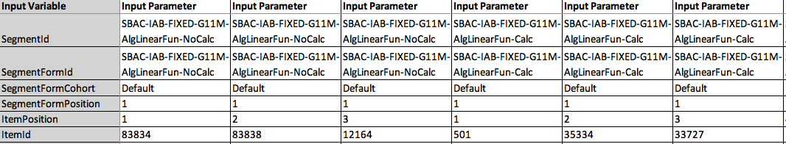

Figure 21: A set of Items from the SegmentForm sheet.

***ItemScore Parameters***

ItemScore Parameters are optional in the SegmentForms sheet. If none are found, they will be retrieved from the GitLab Item metadata’s <IrtDimension> elements. This is, however, an all or nothing scenario in that if the first MeasurementModel_1 Input Variable is defined in the Excel sheet, the FFP will assume that all of the ItemScore Parameters will come from the Excel SegmentForms sheet and not look in GitLab for them. In addition, once a MeasurementModel_{N} is empty in the SegmentForms sheet for that Item, the FFP will stop processing ItemScore Parameters for that Item.

The FFP user can define any number of ItemScoreDimension Groups by adding additional rows to the bottom of the SegmentForms sheet with the additional Input Variables that define an ItemScore Parameter group and incrementing the integer after the underscore in the Input Variable name. The parameters are:

* MeasurementModel_N
* ScorePoints_N
* Dimension_N
* a_N
* b_ N
* b0_ N
* b1_ N
* b2_ N
* b3_ N
* b4_ N
* c_ N

where N is the number of the ItemScoreDimension Group. The values used for N must be sequential (e.g. 1, 2, 3, etc.). If the SegmentForms worksheet has up to MeasurementModel_3 through c_3 defined, and another is needed, copy the last ItemScoreDimension Group’s rows, and paste them below, being careful to increment the trailing integer for those new rows to MeasurementModel_4 through c_4 as seen in Figure 22 and Figure 23.



Figure 22: Adding an additional ItemScoreDimension group.

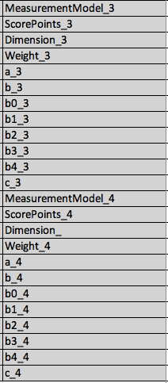

Figure 23: Zoomed in view of the additional ItemScoreDimension group.

### Tools Sheet



Figure 24: The Tools worksheet.

The Tools worksheet (Figure 24) defines the <Tools> and <Tool> entries which may appear within either the <Test> element or the <Segment> element. Tools are associated with either the Test or Segment element by the required entry TestOrSegmentId in the Tools worksheet that much match *either* a Test or SegmentId from the Tests or Segment worksheets. Tools groups can be defined as additional column entries in the Tools worksheet by adding new columns to the right of the worksheet. Individual Tool entries use a numbering convention of <TOOL>_X_Y where X and Y are integer values. The values used for X and Y must be sequential (e.g. 1, 2, 3, etc.). They are defined within a single column by repeating a Tool entry and incrementing the integer value starting with ToolName_N and ending with ToolOptionDependencyDefault_N_2_2 where N increases with the number of Tool entries within a Tools group. For example the third Tool entry within a Tools element would begin with ToolName_3 and end with ToolOptionDefault_3_2 as shown in Figure 25.

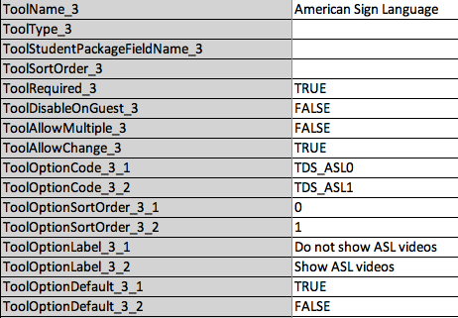

Figure 25: Input Variables and values for a third Tool entry.

|  |  |
| --- | --- |
|  | **Reminder:** The TestOrSegmentId values must match either a TestId or SegmentId from the Tests or Segments worksheet. |

#### Tool Options

A tool may have a number of tool Options defined and several Tool Dependencies within the Options. Additional Tool Options are defined by repeating the ToolOptionCode_X_Y, ToolOptionSortOrder_X_Y, ToolOptionLabel_X_Y, and ToolOptionDefault_X_Y Input Variables within a specific Tool definition where “X” is the Tool number and “Y” is the Option number within that Tool’s Options group. For instance, Figure 25 demonstrates an example of a Tool definition that has two Tool Option entries, the first is defined by the following Input Variables:

* ToolOptionCode_3_1
* ToolOptionSortOrder_3_1
* ToolOptionLabel_3_1
* ToolOptionDefault_3_1

The second group is defined by the following Input Variables:

* ToolOptionCode_3_2
* ToolOptionSortOrder_3_2
* ToolOptionLabel_3_2
* ToolOptionDefault_3_2

The resulting XML elements is shown in Figure 26:

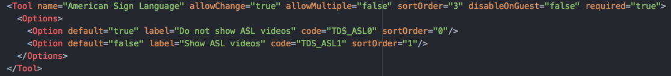

Figure 26: Resulting XML for a Tool definition with 2 Tool Options.

#### Tool Dependencies

Tool Options themselves may optionally have a number of Tool Option Dependencies which can be expanded in a similar fashion to the Tool Options. Tool Option Dependencies are defined by the following trio of Input Variables:

* ToolOptionDependencyIfType_X_Y_Z
* ToolOptionDependencyIfCode_X_Y_Z
* ToolOptionDependencyDefault_X_Y_Z

Where again “X” is the Tool number and “Y” is the Option number, with “Z” defining the number of the Dependency - the values used for X, Y and Z must be sequential (e.g. 1, 2, 3, etc.). For the second Tool in a Tools group that has 2 Tool Option definitions, the first with 3 Dependencies and the second with 2 Dependencies, the Input Variables and values are shown in Figure 27.

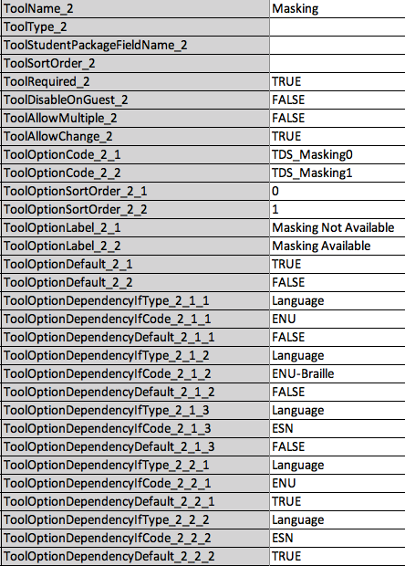

Figure 27: Tool Option Dependency entries for the second Tool in a Tools group.

The resulting XML showing these values is shown in Figure 28.

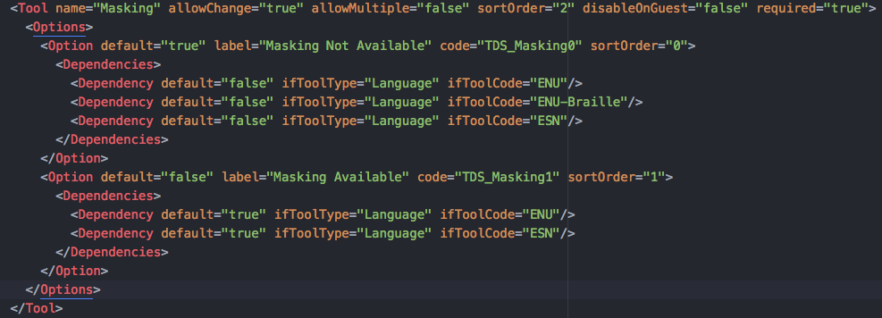

Figure 28: The resulting XML from a Tool definition with multiple Options and multiple Dependencies.